Department of Health Clean Water Branch Polluted Runoff Control Program

Quarterly Status Reporting Form

Clean Water Act 319(h) NPS Implementation Program

Quarterly Status Reports are required per contract terms. If no work was done during the reporting period, the CONTRACTOR must provide an explanation of the circumstances.

This Quarterly Status Report is for the period indicated below **(check only one and insert year)**:

January 1 – March 31, _ ____ (Due April 15th)

April 1- June 30, _________ (Due July 15th)

July 1 – September 30, __2020___ (Due October 15th)

XXXX

October 1 – December 31, _________ (Due January 15th)

Project Title: Implementing Soil Management Strategies and Soil Testing Technologies to Reduce Nutrient Loading for Intensive Farms on Oahu

Project Start/Completion Date: August 2019

Estimated % of Project Completed: 45%

Estimated % of Grant Funds Previously Requested: 0%

Quarterly Status Report Number: 5

Name, telephone number, and e-mail of person to be contacted for questions regarding this report: Jonathan Deenik, 808-956-6906, jdeenik@hawaii.edu

Please provide the following information for this reporting period. Additional sheets may be attached:

1. Progress/tasks started and/or completed as defined in the Contract’s Scope of Services during **current** reporting period.
2. Summary of work completed (list all tasks and deliverables)

|  |  |  |
| --- | --- | --- |
| Task/Deliverable | Due Date | Date Task Completed/  Deliverable Submitted |
| Established additional treatments in corn field at Twin Bridges farm | December 2019 | Completed in Auguat 2020. |
| Established treatments at Kaneshiro and MA”O Farms | December 2019 | Completed June and July 2020. |
| Established second trial at Tolentinos | NA | October 2020 |
| Monitoring soil nitrate status in treatment plots | Ongoing | Monitoring in progress at Twin Bridges, Kaneshiro, and Tolentino farms |
| Monitoring crop yield in treatment plots | Ongoing | Harvest activities in progress at Kahumana, Kaneshiro, MA’O and Tolentino farms |

1. GRTS Load Reductions

|  |  |
| --- | --- |
| Pollutant | Estimated Load Reduction |
| Nitrogen (lbs/yr) | Kahumana Organic Farm:   1. Farmer Practice treatment was a no fertilizer treatment, which reduced N application by 150 lbs N/ac per planting 2. Alternative treatment, reduced ½ feather meal N application by 75 lbs N/ac per planting   Kaneshiro farm:   1. Sunn hemp cover crop and no fertilizer, which reduced N application by 60 lbs N/ac per planting   MA’O Farm:   1. Farmer Practice reduced by ½ equivalent to reduction of 235 lbs N/acre per planting.   Tolentino Farm Trial #2:   1. ¾ Farmer Practice = 200 lbs N/ac reduction per planting. 2. ½ Farmer Practice = 400 lbs N/ac reduction per planting. 3. ¼ Farmer Practice = 600 lbs/N/ac reduction per planting. 4. 1/8 Farmer Practice = 700 lbs N/ac reduction per planting.   Twin Bridges Farm (Sweet Corn):   1. ¾ Farmer Practice = 59 lbs N/ac reduction per planting. 2. ½ Farmer Practice = 117.5 lbs N/ac reduction per planting. |
| Phosphorus (lbs/yr) | MA’O Farm:   1. ½ Farmer Practice = 34.5 lbs P/ac reduction per planting. 2. Feather Meal treatment (12-0-0) = 69 lbs P/ac reduction per planting   Twin Bridges Farm:   1. No P treatments = 31 lbs P/ac reduction per planting |
| Sediment (tons/yr) | Not available |

1. Narrative Progress Report

Kahumana Farm:

* One additional salad mix crop harvest was completed in the demonstration plots.
* Results to date reported back to Farm staff via powerpoint presentation followed by discussion. Event was conducted outdoors and CDC guidelines were strictly adhered to (slide presentation available on demand).

Tolentino Farm:

* No additional harvests were conducted during this reporting period due to heavy thrip infestation, which caused severe damage to eggplant in all demonstration plots.
* A second eggplant demonstration plot was established to assess N fertilizer reductions. Treatments included ¾, ½, ¼, and 1/8 farmer N practice.

Twin Bridge Farm:

* Sweet corn demonstration plot established and planted on 8/13/2020. Sweet corn trial terminated without a harvest on 10/23/2020 due to severe virus damage across of treatment plots.
* Soil nitrate monitoring is ongoing – soil samples for nitrate analysis were collected and measured in the field using the quick test technology at four time points during this reporting period.

Kaneshiro Farm:

* Sunn hemp cover crop biomass recorded and plowed under on 7/31/2020.
* Kai choy crop planted on 8/21/2020 and harvested on 9/11/2020.

Aloun Farm:

* Aloun withdraws from program citing complications due to COVID-19. We have installed extra demonstration plots at Tolentino and MA’O Farms to replace loss.

MA’O Organic Farm:

* One harvest event at MA’O.
* Established second planting.

1. Description of any major issues/problems encountered and/or resolved that may affect the CONTRACTOR’s ability to complete the project as required (i.e., weather, personnel, equipment, etc.). If there is a change in the project timeline or budget, provide an explanation, revised timeline, budget, and completion schedule. (Please note that no-cost extensions must be applied for through the Department, and will only be granted when the CONTRACTOR has demonstrated unforeseeable setbacks.)
2. Statewide stay at home orders due to COVID-19 continue to impact the project as a whole. Due to restrictions on public gatherings we were prohibited from any farmer workshop activities. As an alternative we conducted a socially distanced meeting at Kahumana Farm and Tolentini Farm to report results to date. The meeting consisted of a perpoint slide presentation followed by discussion. The project team is discussing the .
3. With the loss of Aloun Farm as a project demonstration site, we have added a second trial at Tolentino Farm.
4. Pest infestations caused severe damage at Tolentino Farm and Twin Bridges Farm. At Tolentino, the damage was so severe that the eggplant plants were trimmed back in all plots and all plots were given an extra dose of nitrogen to stimulate re-growth. The trimming and nitrogen supplement revived the field. The original N treatments have been re-instated across the plots, and harvest events will begin again in November. The virus pressure in the sweet corn demonstration at Twin Bridges Farm was so severe that he resulted in complete crop failure, and we were not able to collect any yield data.
5. Description of any significant findings, results, or conclusions. If none, please indicate so.

Kahumana Farm

During this reporting period, we have continued to work with Kahumana on refining their organic fertilizer management for mixed salad crops. During the first two demonstration trials (reported in the previous reporting periods), the Farmer Practice treatment began with applied fish/bone meal at a rate to supply 225 lbs N per acre in the first planting, and reduced to 112 lbs N/ac. During this period’s trial, we worked with Kahumana and decided that the Farmer Practice would not receive any fertilizer application, and be compared to a treatment receiving 150 lbs N/ac as fish-meal, a third treatment receiving 75 lbs N/acre as fish-meal, and fourth treatment receiving 75 lbs N/acre as feather meal.

Figure 1 below summarizes fertilizer treatment effects on marketable salad mix yields across three planting cycles.

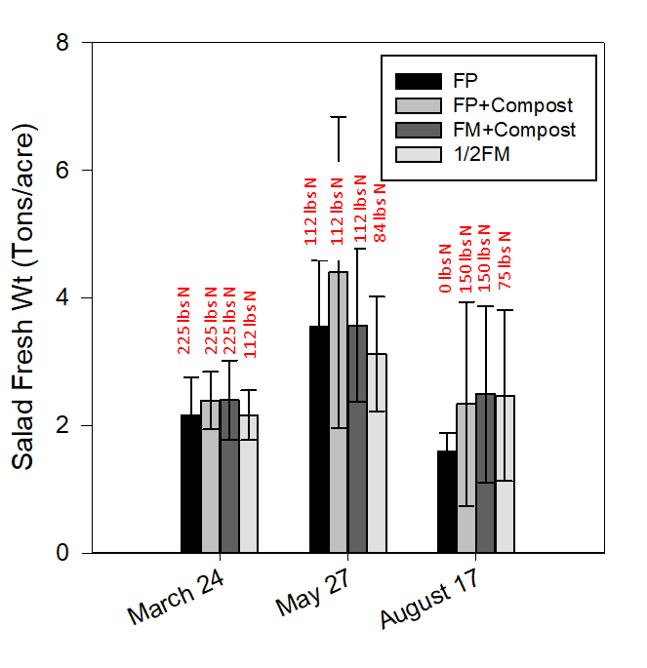

Figure 1. Fertilizer effects on salad yields across three planting cycles. For each cycle, N loading rates are provided for each treatment. Error bars represent the standard error of the mean.

The results displayed in Figure 1 provide a number of key observations regarding organic fertilizer management. First, reducing the Farmer Practice addition of fish/blood meal from 225 lbs N/acre to 112 caused no yield reductions, but rather showed potential for a yield increase. In the third planting cycle the 0 fertilizer plot produced yields comparable to both the high and low fertilizer treatments. All treatments with decreases in fertilizer applications represent potential for large reductions in fertilizer inputs with a substantial reduction in N and P loading without negative impacts on marketable yield. Second, feather meal, which contains no P, produced similar yields to the Farmer Practice at the high N rate and the reduced N rate. These results show the farmer that reducing N inputs and applying no P produces acceptable yields comparable to the high input Farmer Practice.

Kaneshiro Farm

Figure 2 shows the effect of reducing fertilizer N applications with and without a sunn hemp cover crop on pak choi yields. We established the demonstration to assess two N reduction strategies: 1) can N inputs be cut without negatively affecting yields and 2) can N from a sunn hemp cover crop prior to planting supply sufficient N to the cash crop. Analysis of variance found that there were no significant differences between treatments (P<0.05), suggesting that 1) N fertilizer input could be cut by 25% without negative effects on yield and 2) residual in the soil and N from a sunn hemp cover crop shows potential to drastically reduce N fertilizer inputs. However, the sunn hemp and 0 N fertilizer treatment is showing a declining trend in yields.

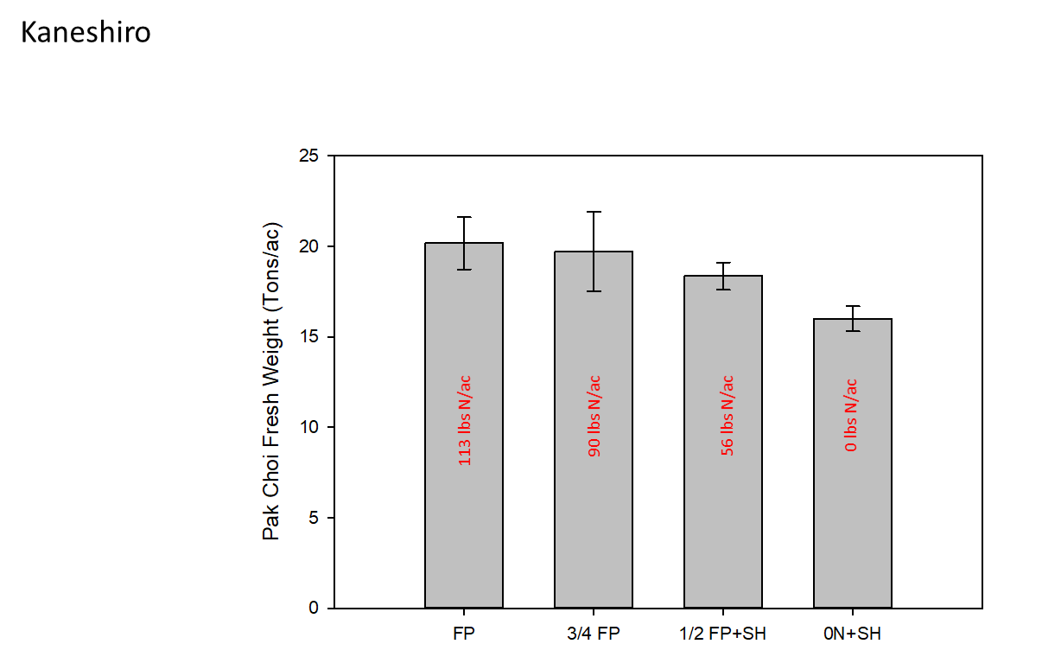

Figure 2. Fertilizer and sunn hemp cover crop effects on pak choi yields. N loading rates are provided for each treatment. Error bars represent the standard error of the mean.

In-field soil nitrate testing at three sampling dates during the pak choi crop showed soil nitrate concentrations ranging from a high of 38 mg kg-1 in the ¾ FP treatment on August 19 to a low of 5 mg kg-1 in the no fertilizer sunn hemp plot (Fig. 3). The 0N fertilizer plot consistently showed the lowest soil nitrate concentrations across sampling dates.

Importantly, the highest N reduction treatments were associated with a sunn hemp cover crop suggesting that N contributions from the sunn hemp can partially substitute for external N fertilizer inputs without negatively affect cash crop yield.

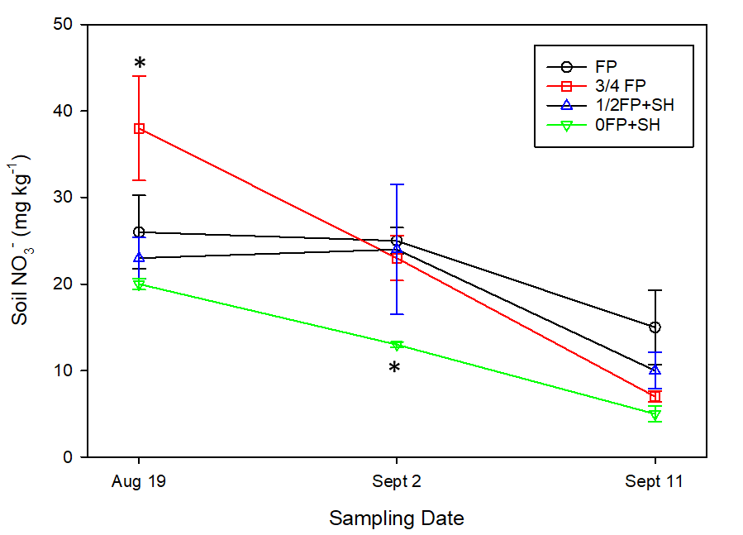

Figure 3. Fertilizer and sunn hemp cover crop effects on soil nitrate concentrations during a pak choi crop. Error bars represent the standard error of the mean and the asterisk denotes significant difference between 0FP+SH and the highest treatment.

MA’O Farm

The demonstration sought to ask two fertilizer questions: 1) can MA’O reduce the amount of N applied and still maintain target crop yields, and 2) can MA’O use an organic fertilizer that contains 0 P and still maintain target crop yields? Figure 4 displays the effect of a high and reduced application of fish-meal tankage (current farmer fertilizer) and feather meal (alternative 0P organic fertilizer) on arugula and mizuna yields. The results suggest two key findings: 1) N input can be cut in half without negatively affecting crop yield, and 2) feather meal, 0P fertilizer, can replace the P-rich tankage product without negatively affecting crop yield.

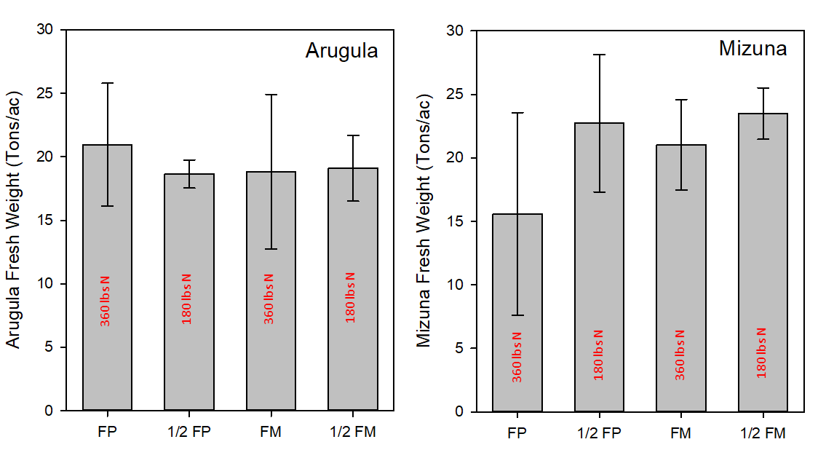

Figure 4. Fertilizer effects arugula and mizuna yields at MA’O Organic Farm. Error bars represent the standard error of the mean.

1. Based on the Scope of Services, a description of tasks expected to be completed in the next reporting period.

Description of tasks for next reporting period:

1. We expect to continue harvest and soil sampling activities at Tolentino, Kahumana, Kaneshiro, and MA’O farms.
2. At Twin Bridges, we expect to continue monthly soil sampling in the asparagus planting and expect the asparagus harvest to occur in December or January. We expect to establish a second demonstration on sweet corn plots.

Summary of expenditures and in-kind contributions previously requested in comparison with the Contract’s project budget and remaining funds. The summary must be actual cumulative amounts for each line item (i.e., personnel services, travel, operating expenses, equipment acquisition, construction materials, other, etc.) current as of this quarterly status report. Please see the example on Page 4 if necessary.

Grant Funds

|  |  |  |  |  |  |
| --- | --- | --- | --- | --- | --- |
| No. | Description | Original Contract Amount | Contract Amounts from Preceding QSR | Expenditures during this Quarterly Reporting Period | Current Contract Amount (Remaining Funds) |
| A | Personnel Services | $244,440.28 | $0 | $26,637.93 | $ |
| B. | Travel | $1560 | $0 | $0 | $ |
| C. | Operating Expenses | $16,830 | $0 | $564.97 | $ |
| D. | Equipment | $1200 | $0 | $0 | $ |
| E. | Professional Services | $14,420 | $0 | $242.93 | $ |
| F. | Construction Materials and Supplies | $0 | $0 | $0 | $ |
| G. | Other Misc. Expenses | $1500 | $0 | $0 | $ |

TOTALS $279,950.28 $0.00 $27,445.83

$200,142.52

In-Kind Contributions (Matching Funds)

|  |  |  |  |  |  |
| --- | --- | --- | --- | --- | --- |
| No. | Description | Original Contribution Amounts | Contribution Amounts from Preceding QSR | Contributions during this Quarterly Reporting Period | Current Contribution Amount |
| A | Personnel Services | $94,461.44 | $1,876.14 | $7,915.8 | $ |
| B. | Travel | $ | $ | $ | $ |
| C. | Operating Expenses | $ | $ | $ | $ |
| D. | Equipment | $ | $ | $ | $ |
| E. | Professional Services | $ | $ | $ | $ |
| F. | Construction Materials and Supplies | $ | $ | $ | $ |
| G. | Other Misc. Expenses | $ | $ | $ | $ |

TOTALS $94,461.44 $1,876.14 $7,915.8

$81,542.6

In this ***example***, the Contract’s overall project budget for Personnel Services is $10,000.00, with $15,000.00 in Match. The Travel Budget is $1,200.00 with $1,000.00 in Match. Due to space constraints, Categories C - G were not listed in this example but shall be included with official QSRs and reimbursement requests. In the first Quarterly Grant Expense Report, the CONTRACTOR requests a $500.00 reimbursement, and claims $200.00 in Match:

Grant Funds

|  |  |  |  |  |  |
| --- | --- | --- | --- | --- | --- |
| No. | Description | Original Contract Amount | Contract Amounts from Preceding QSR | Expenditures during this Quarterly Reporting Period | Current Contract Amount (Remaining Funds) |
| A | Personnel Services | $10,000.00 | $0.00 | $500.00 | $9,500.00 |
| B | Travel | $1,200.00 | $0.00 | $0.00 | $1,200.00 |

TOTALS $11,200.00 $0.00 $500.00 $10,700.00

In-Kind Contributions (Matching Funds)

|  |  |  |  |  |  |
| --- | --- | --- | --- | --- | --- |
| No. | Description | Original Contribution Amounts | Contribution Amounts from Preceding QSR | Contributions during this Quarterly Reporting Period | Current Contribution Amount |
| A | Personnel Services | $15,000.00 | $0.00 | $200.00 | $14,800.00 |
| B | Travel | $1,000.00 | $0.00 | $0.00 | $1,000.00 |

TOTALS $16,000.00 $0.00 $200.00 $15,800.00

With QSR #2, the CONTRACTOR requests a $1,500.00 reimbursement and claims $500.00 in Match for Personnel, and $200.00 in Match for Travel (Note that the “Original Contract Amount” Column never changes, and the “Contract Amounts from Preceding QSR” Column in QSR #2 is identical to the “Current Contract Amounts” Column in QSR #1):

Grant Funds

|  |  |  |  |  |  |
| --- | --- | --- | --- | --- | --- |
| No. | Description | Original Contract Amount | Contract Amounts from Preceding QSR | Expenditures during this Quarterly Reporting Period | Current Contract Amount (Remaining Funds) |
| A | Personnel Services | $10,000.00 | $9,500.00 | $1,500.00 | $8,000.00 |
| B | Travel | $1,200.00 | $1,200.00 | $0.00 | $1,200.00 |

TOTALS $11,200.00 $10,700.00 $1,500.00 $9,200.00

In-Kind Contributions (Matching Funds)

|  |  |  |  |  |  |
| --- | --- | --- | --- | --- | --- |
| No. | Description | Original Contribution Amounts | Contribution Amounts from Preceding QSR | Contributions during this Quarterly Reporting Period | Current Contribution Amount |
| A | Personnel Services | $15,000.00 | $14,800.00 | $500.00 | $14,300.00 |
| B | Travel | $1,000.00 | $1,000.00 | $200.00 | $800.00 |

TOTALS $16,000.00 $15,800.00 $700.00 $15,100.00