Department of Health Clean Water Branch Polluted Runoff Control Program

Quarterly Status Reporting Form

Clean Water Act 319(h) NPS Implementation Program

Quarterly Status Reports are required per contract terms. If no work was done during the reporting period, the CONTRACTOR must provide an explanation of the circumstances.

This Quarterly Status Report is for the period indicated below **(check only one and insert year)**:

January 1 – March 31, _ ____ (Due April 15th)

April 1- June 30, _________ (Due July 15th)

July 1 – September 30, __ ___ (Due October 15th)

XXXX

October 1 – December 31, __2020___ (Due January 15th)

Project Title: Implementing Soil Management Strategies and Soil Testing Technologies to Reduce Nutrient Loading for Intensive Farms on Oahu

Project Start/Completion Date: August 2019

Estimated % of Project Completed: 55%

Estimated % of Grant Funds Previously Requested: 0%

Quarterly Status Report Number: 6

Name, telephone number, and e-mail of person to be contacted for questions regarding this report: Jonathan Deenik, 808-956-6906, jdeenik@hawaii.edu

Please provide the following information for this reporting period. Additional sheets may be attached:

1. Progress/tasks started and/or completed as defined in the Contract’s Scope of Services during **current** reporting period.
2. Summary of work completed (list all tasks and deliverables)

|  |  |  |
| --- | --- | --- |
| Task/Deliverable | Due Date | Date Task Completed/  Deliverable Submitted |
| Reported trial results to Kahumana Farms and Tolentino Farm | Ongoing | This reporting cycle |
| Established treatments at Kaneshiro and MA”O Farms | December 2019 | Completed June and July 2020. |
| Re-started eggplant trial #1 | NA | NA |
| Monitoring soil nitrate status in treatment plots | Ongoing | Monitoring in progress at Twin Bridges, Kahumana, and MA’O farms |
| Monitoring crop yield in treatment plots | Ongoing | Harvest activities in progress at MA’O, Twin Bridges, and Kahumana farms |

1. GRTS Load Reductions

|  |  |
| --- | --- |
| Pollutant | Estimated Load Reduction |
| Nitrogen (lbs/yr) | Kahumana Organic Farm:  No crop harvests during this reporting period  Kaneshiro farm:  No crop harvests during this reporting period  MA’O Farm:   1. Farmer Practice reduced by ½ equivalent to reduction of 235 lbs N/acre per planting.   Twin Bridges Farm (Sweet Corn):   1. First sweet corn trial established with alternative treatments representing a reduction of 59 and 118 lbs N per acre for the 75% and 50% farmer practice fertilization. |
| Phosphorus (lbs/yr) | MA’O Farm:   1. ½ Farmer Practice = 34.5 lbs P/ac reduction per planting. 2. Feather Meal treatment (12-0-0) = 69 lbs P/ac reduction per planting   Twin Bridges Farm (Sweet Corn):   1. The two alternative treatments received 0 P additions represent a reduction of 15.6 lbs P per acre |
| Sediment (tons/yr) | Not available |

1. Narrative Progress Report

Kahumana Farm:

* Demonstration trial results from project initiation up to summer 2020 were presented at Kahumana Organic Farm on October 6, 2020. Participants included farm staff and interns. The event conformed to CDC guidelines (socially distanced seating and mask wearing). The powerpoint presentation is as a separate pdf attachment.
* Met with farm manager at Kahumana to discuss project progress and trial as it moves forward. The manager was happy with current progress and looks forward to the continuation of the demonstration trials.
* New salad mix trial established October 12, 2020, but it had to be terminated on October 27 due to heavy rainfall events which caused poor germination.
* Beet experiment established on December 12, 2020.

Tolentino Farm:

* Project results highlighting fertilizer effects on eggplant production presented to the Tolentinos on October 6, 2020.
* Established second eggplant fertilizer demonstration plots replicating the first trial on October 12, 2020.
* Eggplant harvest conducted in trial #1 plots on November 30, 2020. Eggplant production heavily impacted by pest infestations (see results in Section 3 below).

Twin Bridge Farm:

* The first fertilizer reduction trial on sweet corn had to be terminated due to severe crop damage from virus infestation.
* The second fertilizer reduction trial on sweet corn was planted in a new field on November 14, 2020.

Kaneshiro Farm:

* No activities this reporting period.

Aloun Farm:

* Met with Mr. Alec Siu, owner of Aloun Farm, and he is confident our work with them will begin in January.

MA’O Organic Farm:

* Two kale harvests conducted (Oct. 23 and Nov. 23).
* Planted new demonstration plots with salad mix on Dec. 30.

1. Description of any major issues/problems encountered and/or resolved that may affect the CONTRACTOR’s ability to complete the project as required (i.e., weather, personnel, equipment, etc.). If there is a change in the project timeline or budget, provide an explanation, revised timeline, budget, and completion schedule. (Please note that no-cost extensions must be applied for through the Department, and will only be granted when the CONTRACTOR has demonstrated unforeseeable setbacks.)
2. Statewide stay at home orders due to COVID-19 continue to impact the project as a whole. Due to restrictions on public gatherings we were prohibited from any farmer workshop activities. As an alternative we conducted a socially distanced meeting at Kahumana Farm and Tolentino Farm to report results to date. The meeting consisted of a powerpoint slide presentation followed by discussion at Kahumana. At Tolentino Farm, the PI and extension agent Joshua Silva printed out graphs of harvest data and soil nitrate data, which were shared and explained directly to Mr. and Mrs. Tolentino.
3. Pest infestations at Tolentino Farm and Twin Bridges Farm continue to cause major problems. At Tolentino, trimmed eggplant plots did not result in crop recovery. The harvest event on Nov. 30 saw a dramatic decrease in eggplant yield across all demonstration plots (see results below). The second eggplant demonstration plots planted on October 12, 2020, were also heavily impacted by white fly infestation in December, and it is unlikely we will be able to gather any data in those plots. We have initiated plans to continue the demonstration plots using taro as the test crop. The virus pressure in the first sweet corn demonstration at Twin Bridges Farm was so severe that it resulted in complete crop failure, and we were not able to collect any yield data. A second demonstration with sweet corn was planted on November 14, 2020, and we hope it will not be affected by the virus. However, it has become increasingly difficult to grow sweet corn on Oahu due to virus proliferation.

Heavy rainfall events at Kahumana at the end of October destroyed the salad mix crop demonstration that had been planted in early October. Nonetheless, we continue to work well with Kahumana, and have established another set of demonstration plots with beets.

1. Description of any significant findings, results, or conclusions. If none, please indicate so.

Tolentino Farm

One eggplant harvest took place at Tolentino Farm on November 30 during this reporting period. Severe white fly and other pest issues have caused dramatic declines in eggplant yields regardless of fertilizer treatment (Figure 1).



Figure 1. The effect of reducing fertilizer additions on eggplant yields at Tolentino Farm. The dramatic decline in yield on November 30 was due to severe pest infestation in all fertilizer plots.

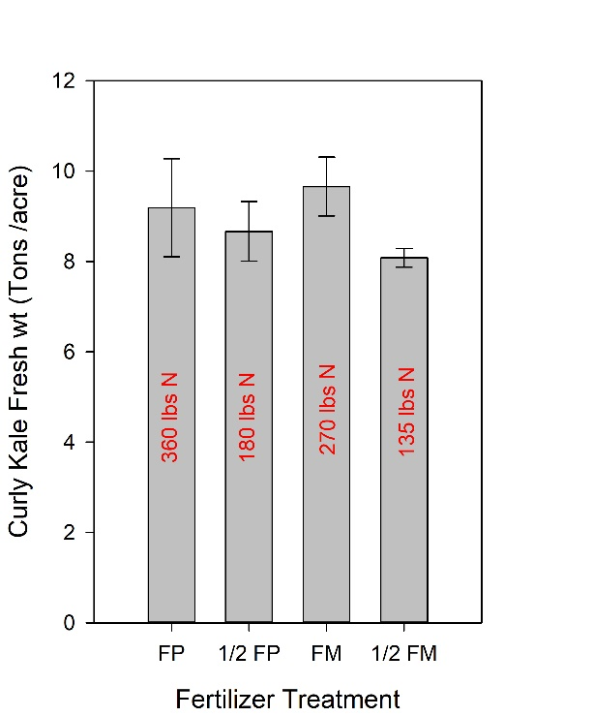

MA’O Farm

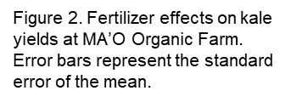As reported in the previous reporting period, reducing fertilizer N and P additions did not reduce vegetable yields. Figure 2 shows kale yields for the different fertilizer treatments. The Farmer Practice (FP) treatments supplied 360 and 180 lbs N per acre via tankage fertilizer, and yields were approximately equal. The feather meal treatments supplied 270 and 135 lbs N per acre and 0 P without causing a significant decline in yields. The feather meal contains no P and serves as an excellent nitrogen fertilizer in organic systems where P build up is common when applying most certified organic fertilizers, which tend to contain high P.

Twin Bridges Farm

At Twin Bridges farm in Waialua, we have been taking periodic soil nitrate measurements in the asparagus demonstration plots. The treatments are designed to eliminate P fertilizer given the high residual P concentration in the soils and also reduce nitrogen fertilizer use. The panels in Figure 3 show nitrate concentration in the top 15 cm of the soil in the four different fertilizer plots over a

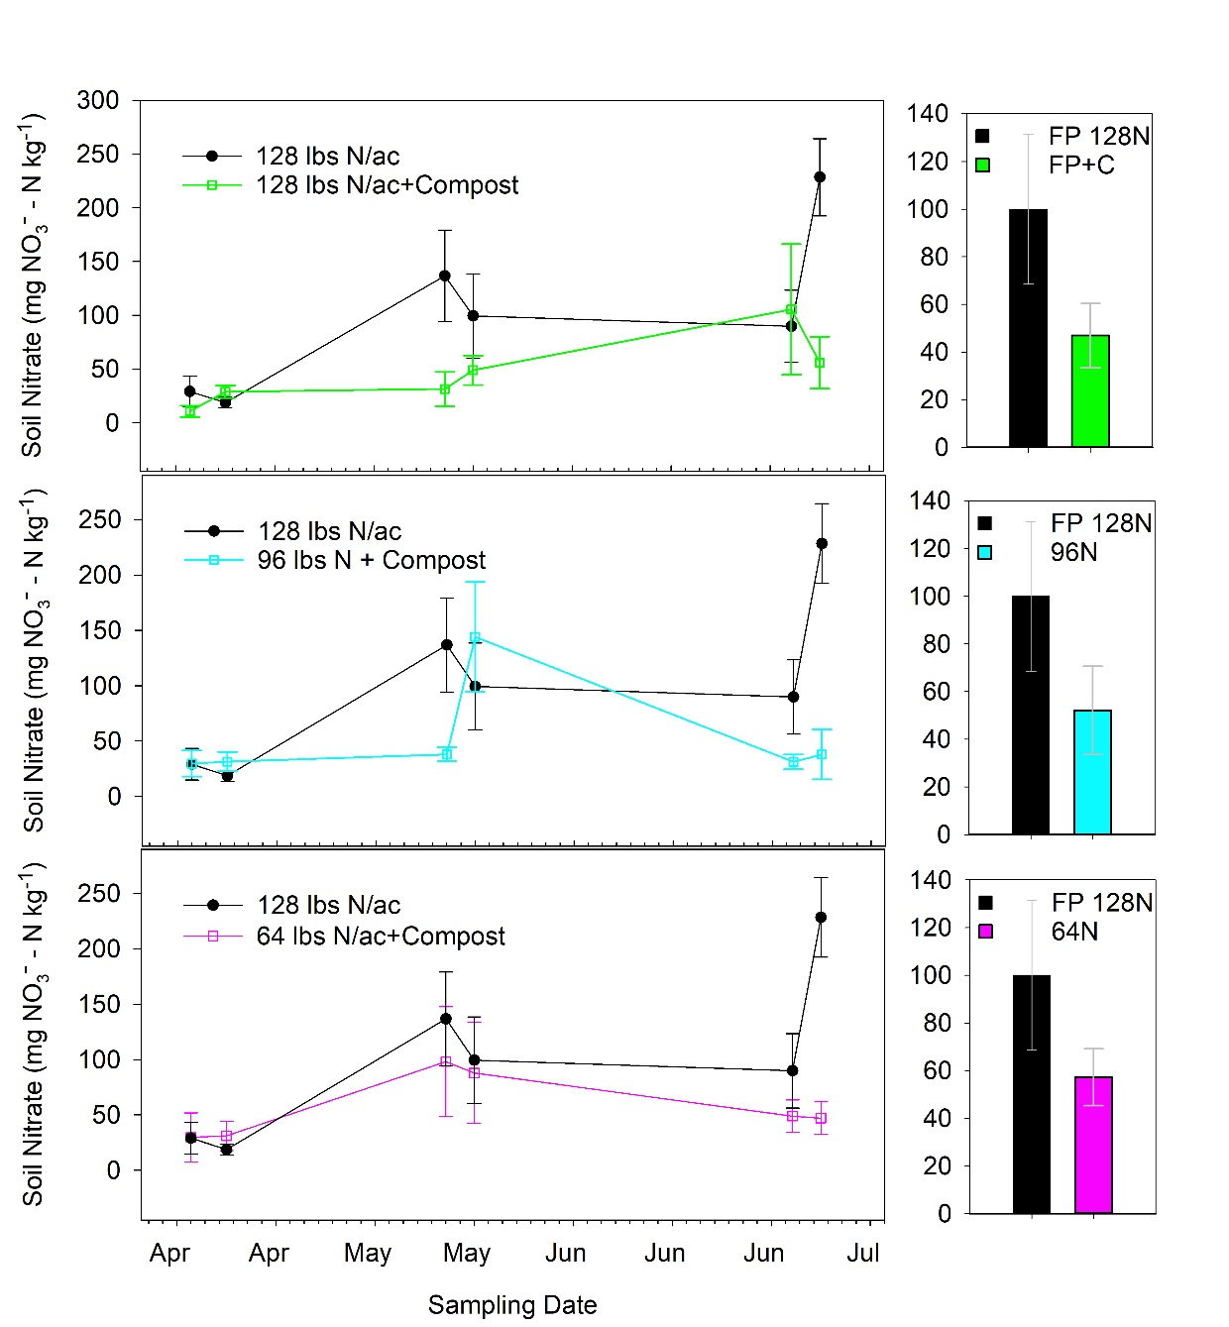

Figure 3. Fertilizer treatment effects on soil nitrate concentration in the 0-15 cm depth over a three month period (left-hand panels) and average nitrate concentration in the same depth during the sampling period (right-hand panels).

a three-month period. In the top left panel, we see that adding compost reduces nitrate in the root zone across most sampling dates resulting in a 50% reduction in average soil nitrate concentration from 100 mg NO3- -N kg-1 to 46.9 NO3- -N kg-1 (top right-hand panel). We speculate that the microbial activity stimulated by the compost application assimilated soil nitrate. Reducing N fertilizer application by 75% (middle panels) and 50% (bottom panels) also showed 50% reduction in soil nitrate concentration. Visually, the asparagus in all treatment plots look healthy and show no signs of nitrogen deficiency.

Kahumana Organic Farm

Below (Figure 4) we report the results of soil nitrate sampling in the root crop trial that took place between October and December of 2019. In that demonstration trial, the Farmer Practice (FP) applied no fertilizer. We compared the FP with recommended rates of tankage and feather meal to supply 150 lbs N per acre at full dose and a half dose of feather meal (75 lbs N). The tankage treatment had no significant effect on soil nitrate concentration during the two-month growing

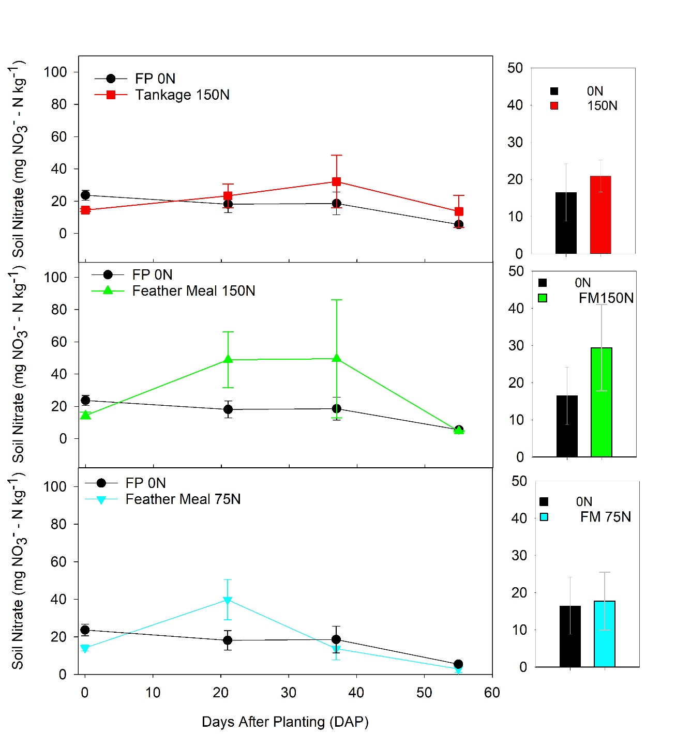

Figure 4. Fertilizer treatment effects on soil nitrate concentration in the 0-15 cm depth over a three month period (left-hand panels) and average nitrate concentration in the same depth during the sampling period (right-hand panels).

period whereas the full dose feather meal fertilizer increased average soil nitrate concentration from 16.5 mg NO3- -N kg-1 to 29.4 mg NO3- -N kg-1 representing a nearly two-fold increase. The half dose of feather meal did not raise soil nitrate concentration above the 0 fertilizer treatment. We have already reported that fertilizer inputs did not increase root yields compared with the non-fertilized Farmer Practice indicating that for root crops residual or native soil fertility can sustain target yields.

1. Based on the Scope of Services, a description of tasks expected to be completed in the next reporting period.

Description of tasks for next reporting period:

1. New demonstration plots have been planted at Kahumana and MA’O farms, which will be harvested in the next reporting period. We also expect to conduct our first asparagus harvest at Twin Bridges Farm.
2. We have a second trial scheduled to be planted at Owen Kaneshiro Farm in February.
3. We have selected a field at Aloun Farm to set up demonstration plota and expect the won bok to be planted by the third week of February.
4. Given the failure of two corn crops at Twin Bridges Farm, we are discussing an appropriate crop to use with the farm manager.
5. We will continue monitoring soil nitrate status in demonstration plots at all sites.

Summary of expenditures and in-kind contributions previously requested in comparison with the Contract’s project budget and remaining funds. The summary must be actual cumulative amounts for each line item (i.e., personnel services, travel, operating expenses, equipment acquisition, construction materials, other, etc.) current as of this quarterly status report. Please see the example on Page 4 if necessary.

Grant Funds

|  |  |  |  |  |  |
| --- | --- | --- | --- | --- | --- |
| No. | Description | Original Contract Amount | Contract Amounts from Preceding QSR | Expenditures during this Quarterly Reporting Period | Current Contract Amount (Remaining Funds) |
| A | Personnel Services | $244,440.28 | $0 | $20,142.59 | $ |
| B. | Travel | $1560 | $0 | $0 | $ |
| C. | Operating Expenses | $16,830 | $0 | $1,491.72 | $ |
| D. | Equipment | $1200 | $0 | $0 | $ |
| E. | Professional Services | $14,420 | $0 | $337.17 | $ |
| F. | Construction Materials and Supplies | $0 | $0 | $0 | $ |
| G. | Other Misc. Expenses | $1500 | $0 | $0 | $ |

TOTALS $279,950.28 $0.00 $21,971.48

$178,171.04

In-Kind Contributions (Matching Funds)

|  |  |  |  |  |  |
| --- | --- | --- | --- | --- | --- |
| No. | Description | Original Contribution Amounts | Contribution Amounts from Preceding QSR | Contributions during this Quarterly Reporting Period | Current Contribution Amount |
| A | Personnel Services | $94,461.44 | $7,915.8 | $15,831.6 | $ |
| B. | Travel | $ | $ | $ | $ |
| C. | Operating Expenses | $ | $ | $ | $ |
| D. | Equipment | $ | $ | $ | $ |
| E. | Professional Services | $ | $ | $ | $ |
| F. | Construction Materials and Supplies | $ | $ | $ | $ |
| G. | Other Misc. Expenses | $ | $ | $ | $ |

TOTALS $94,461.44 $7,915.8 $15,831.6

$65,711

In this ***example***, the Contract’s overall project budget for Personnel Services is $10,000.00, with $15,000.00 in Match. The Travel Budget is $1,200.00 with $1,000.00 in Match. Due to space constraints, Categories C - G were not listed in this example but shall be included with official QSRs and reimbursement requests. In the first Quarterly Grant Expense Report, the CONTRACTOR requests a $500.00 reimbursement, and claims $200.00 in Match:

Grant Funds

|  |  |  |  |  |  |
| --- | --- | --- | --- | --- | --- |
| No. | Description | Original Contract Amount | Contract Amounts from Preceding QSR | Expenditures during this Quarterly Reporting Period | Current Contract Amount (Remaining Funds) |
| A | Personnel Services | $10,000.00 | $0.00 | $500.00 | $9,500.00 |
| B | Travel | $1,200.00 | $0.00 | $0.00 | $1,200.00 |

TOTALS $11,200.00 $0.00 $500.00 $10,700.00

In-Kind Contributions (Matching Funds)

|  |  |  |  |  |  |
| --- | --- | --- | --- | --- | --- |
| No. | Description | Original Contribution Amounts | Contribution Amounts from Preceding QSR | Contributions during this Quarterly Reporting Period | Current Contribution Amount |
| A | Personnel Services | $15,000.00 | $0.00 | $200.00 | $14,800.00 |
| B | Travel | $1,000.00 | $0.00 | $0.00 | $1,000.00 |

TOTALS $16,000.00 $0.00 $200.00 $15,800.00

With QSR #2, the CONTRACTOR requests a $1,500.00 reimbursement and claims $500.00 in Match for Personnel, and $200.00 in Match for Travel (Note that the “Original Contract Amount” Column never changes, and the “Contract Amounts from Preceding QSR” Column in QSR #2 is identical to the “Current Contract Amounts” Column in QSR #1):

Grant Funds

|  |  |  |  |  |  |
| --- | --- | --- | --- | --- | --- |
| No. | Description | Original Contract Amount | Contract Amounts from Preceding QSR | Expenditures during this Quarterly Reporting Period | Current Contract Amount (Remaining Funds) |
| A | Personnel Services | $10,000.00 | $9,500.00 | $1,500.00 | $8,000.00 |
| B | Travel | $1,200.00 | $1,200.00 | $0.00 | $1,200.00 |

TOTALS $11,200.00 $10,700.00 $1,500.00 $9,200.00

In-Kind Contributions (Matching Funds)

|  |  |  |  |  |  |
| --- | --- | --- | --- | --- | --- |
| No. | Description | Original Contribution Amounts | Contribution Amounts from Preceding QSR | Contributions during this Quarterly Reporting Period | Current Contribution Amount |
| A | Personnel Services | $15,000.00 | $14,800.00 | $500.00 | $14,300.00 |
| B | Travel | $1,000.00 | $1,000.00 | $200.00 | $800.00 |

TOTALS $16,000.00 $15,800.00 $700.00 $15,100.00