Department of Health Clean Water Branch Polluted Runoff Control Program

Quarterly Status Reporting Form

Clean Water Act 319(h) NPS Implementation Program

Quarterly Status Reports are required per contract terms. If no work was done during the reporting period, the CONTRACTOR must provide an explanation of the circumstances.

This Quarterly Status Report is for the period indicated below **(check only one and insert year)**:

January 1 – March 31, _ 2021____ (Due April 15th)

April 1- June 30, _________ (Due July 15th)

July 1 – September 30, __ ___ (Due October 15th)

XXXX

October 1 – December 31, __ ___ (Due January 15th)

Project Title: Implementing Soil Management Strategies and Soil Testing Technologies to Reduce Nutrient Loading for Intensive Farms on Oahu

Project Start/Completion Date: August 2019

Estimated % of Project Completed: 60%

Estimated % of Grant Funds Previously Requested: 0%

Quarterly Status Report Number: 7

Name, telephone number, and e-mail of person to be contacted for questions regarding this report: Jonathan Deenik, 808-956-6906, jdeenik@hawaii.edu

Please provide the following information for this reporting period. Additional sheets may be attached:

1. Progress/tasks started and/or completed as defined in the Contract’s Scope of Services during **current** reporting period.
2. Summary of work completed (list all tasks and deliverables)

|  |  |  |
| --- | --- | --- |
| Task/Deliverable | Due Date | Date Task Completed/  Deliverable Submitted |
| Reported trial results to MA’O Farm | Ongoing | This reporting cycle |
| Established treatments at Aloun Farms | December 2019 | Completed February 2021. |
| Monitoring soil nitrate status in treatment plots | Ongoing | Monitoring in progress at Aloun Farm |
| Monitoring crop yield in treatment plots | Ongoing | Harvest activities in progress at MA’O, Kahumana farms, and Aloun Farm |
| Planted second round of sunn hemp cover crop at Kaneshiro Farm | Ongoing | Ongoing |

1. GRTS Load Reductions

|  |  |
| --- | --- |
| Pollutant | Estimated Load Reduction |
| Nitrogen (lbs/yr) | Kahumana Organic Farm:  Beet trial established with the following treatments: Full fish/bone meal (150 lbs N/ac, 45 lbs P), Full Feather Meal (150 lbs N/ac, 0 P), ½ fish/bone meal (75 lbs N/ac, 27 lbs P/ac), ½ Feather Meal (75 lbs N/ac, 0P), no fertilizer (0 N, 0 P). N load reduction: 75 lbs N/ac  Kaneshiro farm:  Cover crop grown and incorporated  MA’O Farm:  Farmer Practice reduced by ½ equivalent to reduction of 235 lbs N/acre per planting.  Aloun Farm (won bok crop):  Won bok trial established with the following treatments: Farmer Practice (Full N and P, 350 lbs N/ac), Treatment 1 (290 lbs N/ac + Pre-plant P), Treatment 2 (290 lbs N/ac, 0 P), Treatment 3 (200 lbs N/ac, 0 P), Treatment 4 (175 lbs N/ac, 0 P). N load reduction: T1 and T2 = 60 lbs N/ac, T3 = 150 olbs N/ac), T4 = 175 lbs N/ac). |
| Phosphorus (lbs/yr) | MA’O Farm:   1. ½ Farmer Practice = 34.5 lbs P/ac reduction per planting. 2. Feather Meal treatment (12-0-0) = 69 lbs P/ac reduction per planting   Aloun Farm (won bok crop):  T1 reduced P load by 92 lbs/ac. T2-T4 reduced P load by 132 lbs P/ac. |
| Sediment (tons/yr) | Not available |

1. Narrative Progress Report

Kahumana Farm:

* Fertilizer treatments for Beet trial added at the end of December. Treatments included: 1) Full dose of fish/bone meal (N = 150 lbs N/ac, 45 lbs P/ac), 2) ½ fish/bone meal (N = 75 lbs N/ac, 27 lbs P/ac), 3) Full dose of feather meal (N = 150 lbs N/ac, 0 lbs P/ac), 4) N = 75 lbs N/ac, 0 lbs P/ac), and 5) No fertilizer. Beets planted.
* Beets were harvested and harvest data collected on March 17, 2021.

Tolentino Farm:

* First demonstration plots on eggplant terminated due to heavy pest infestation.
* Second eggplant demonstration trial (planted in October 2020) removed due to irreversible plant damaged caused by heavy pest infestation followed by excessive rains in February.
* Plans to re-plant eggplant trial in progress.

Twin Bridge Farm:

* The second fertilizer reduction trial on sweet corn was planted in a new field on November 14, 2020, but was terminated in February, 2021 due to severe crop damage from virus infestation.

Kaneshiro Farm:

* Second sunn hemp crop was planted end of March 2021. The second fertilizer trial will follow in May, 2021.

MA’O Organic Farm:

* Three salad harvests occurred (Jan 22, Jan 29, and Feb 5, 2021). Data recorded.
* Trial results reported back to MA’O Farm Manager and Assistant Manager on March 31, 2021. The next fertilizer trials will move to the original MA’O fields established in 2002.

Aloun Farm:

* Won bok fertilizer trial planted on Feb 26, 2021 in Kunia. Treatments are outlined in Table below along with the plot layout.

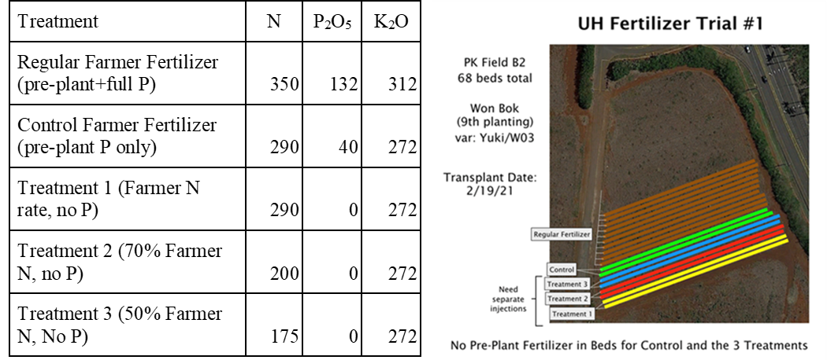

* Soil nitrate monitoring events occurred at 6 time points during the won bok crop cycle.
* The crop was harvested and biomass data collected on 4/15, 2021.

1. Description of any major issues/problems encountered and/or resolved that may affect the CONTRACTOR’s ability to complete the project as required (i.e., weather, personnel, equipment, etc.). If there is a change in the project timeline or budget, provide an explanation, revised timeline, budget, and completion schedule. (Please note that no-cost extensions must be applied for through the Department, and will only be granted when the CONTRACTOR has demonstrated unforeseeable setbacks.)
2. Pest infestations at Tolentino Farm and Twin Bridges Farm continue to cause major problems. At Tolentino Farm, the initial eggplant trial was terminated and the second trial planted in December 2020 was also terminated because of excessive pest damage combined with excessive rains in January and February, 2021. We have initiated plans to continue the demonstration plots using taro as the test crop. The virus pressure in the second sweet corn demonstration at Twin Bridges Farm was as severe as the first corn planting, which resulted in complete crop failure, and we were not able to collect any yield data. It has become increasingly difficult to grow sweet corn on Oahu due to virus proliferation. We are in discussion with Twin Bridges to find an alternative crop. COVID-19 has also severely impacted the demand for vegetables adding to the difficulty of getting the trials established at Twin Bridges.
3. Heavy rains in January and February delayed implementation of trials at Kahumana, MA’O, Twin Bridges and Kaneshiro Farms.
4. Description of any significant findings, results, or conclusions. If none, please indicate so.

MA’O Farm

Fertilizer treatment effects on three salad mix harvests are displayed in the figure below. At all three harvest dates the full dose of fish/bone meal and feather meal produced the same harvestable yield. At the first two harvest dates (1/22 and 1/26), there was no effect of fertilizer on salad yield, but on the last harvest date the ½ feather meal treatment caused a significant reduction in salad yield. The data suggest, that over the three harvest dates the ½ feather meal may not be supplying adequate N to ensure consistent high yields. At the same time, the data clearly supports the recommendation to use a fertilizer material such as feather meal that did not contain P.

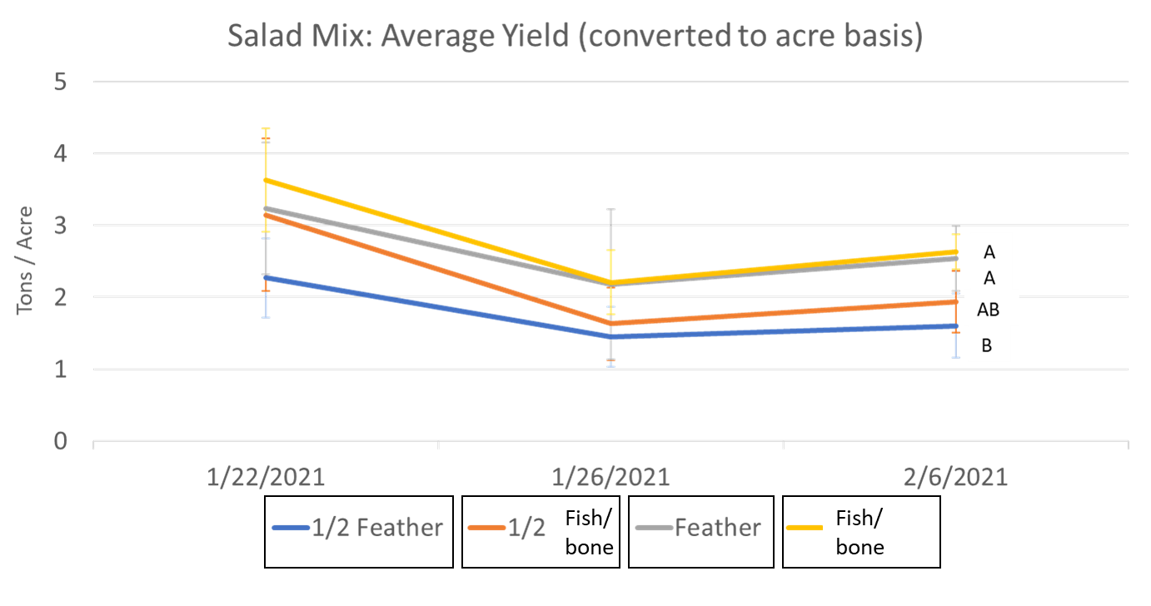

Kahumana Organic Farm

In the figure below we present a boxplot summarizing fertilizer treatment effects on beet yield. Based upon our harvest data, there were no yield differences among the fertilizer treatments. In fact, as in previous root crop trials conducted in 2020, the no fertilizer plots performed as well as the plots receiving fertilizer inputs. Here we provide further evidence that the grower can forego fertilizer applications when growing a root crop; there is enough residual nutrient supply to maintain target root yields.

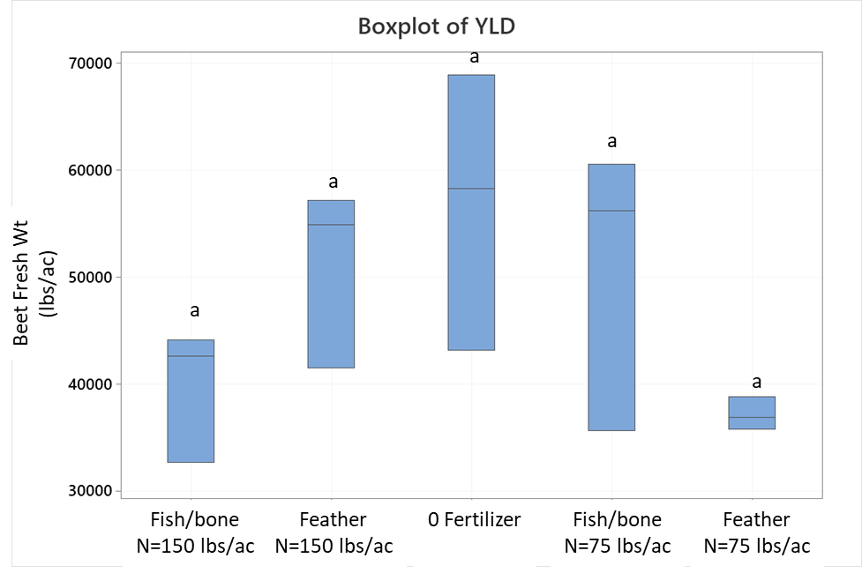

Aloun Farm

In Figure 1 below we present a boxplot summarizing fertilizer treatment effects on won bok yield. Based upon our harvest data, there were no yield differences among the controls with and without pre-plant fertilizer, the control without P (Treatment 1) and the 70% N without P treatment (Treatment 2). The lowest N treatment (Treatment 3) resulted in significantly lower yields than the Control+Pre-plant, Treatment 2 and Control without P treatments. The results suggest three important outcomes: 1) a pre-plant fertilizer application is not necessary; 2) leaving P out of the fertilizer formulation is possible without adversely affecting crop yield, and 3) N application can be reduced by 30% without a negative effect on won bok yield, but cutting N application in half is too much of a reduction, which led to significantly lower won bok yield.

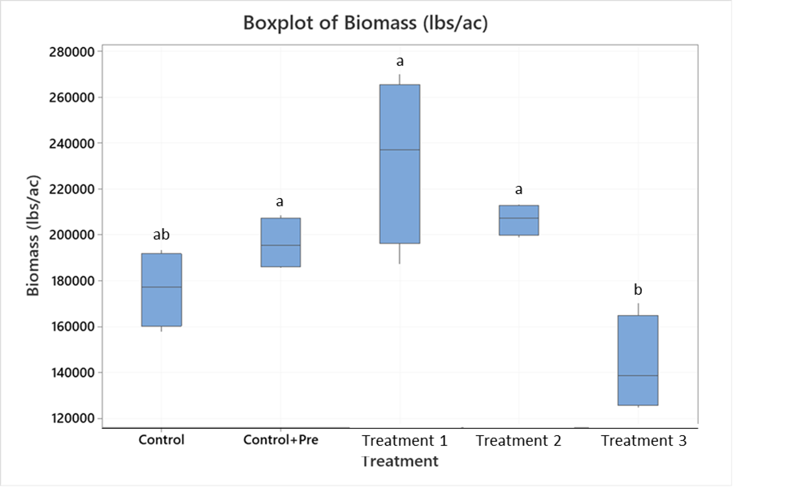

Figure 1. Fertilizer treatment effects on won bok yields. Bars containing the same letters are not significantly different (P<0.05).

1. Based on the Scope of Services, a description of tasks expected to be completed in the next reporting period.

Description of tasks for next reporting period:

1. New demonstration plots will be established at MA’O farms, and planted during the next reporting period.
2. Given an unpredictable market, the asparagus harvest at Twin Bridges Farm was delayed until the next reporting period. We continue to work with Twin Bridges staff to identify a suitable replacement crop to corn given the failure of our two corn plantings.
3. The second pak choy trial will be planted at Owen Kaneshiro Farm in May/June.
4. We have planned two more trials at Aloun Farm, one in Kunia and the other in Helemano, which will be planted in May/June.
5. We will continue monitoring soil nitrate status in demonstration plots at all sites.

Summary of expenditures and in-kind contributions previously requested in comparison with the Contract’s project budget and remaining funds. The summary must be actual cumulative amounts for each line item (i.e., personnel services, travel, operating expenses, equipment acquisition, construction materials, other, etc.) current as of this quarterly status report. Please see the example on Page 4 if necessary.

Grant Funds

|  |  |  |  |  |  |
| --- | --- | --- | --- | --- | --- |
| No. | Description | Original Contract Amount | Contract Amounts from Preceding QSR | Expenditures during this Quarterly Reporting Period | Current Contract Amount (Remaining Funds) |
| A | Personnel Services | $244,440.28 | $0 | $14,899.52 | $ |
| B. | Travel | $1560 | $0 | $0 | $ |
| C. | Operating Expenses | $16,830 | $0 | $1,110.01 | $ |
| D. | Equipment | $1200 | $0 | $0 | $ |
| E. | Professional Services | $14,420 | $0 | $0 | $ |
| F. | Construction Materials and Supplies | $0 | $0 | $0 | $ |
| G. | Other Misc. Expenses | $1500 | $0 | $0 | $ |

TOTALS $279,950.28 $0.00 $15,009.53

$163,161.51

In-Kind Contributions (Matching Funds)

|  |  |  |  |  |  |
| --- | --- | --- | --- | --- | --- |
| No. | Description | Original Contribution Amounts | Contribution Amounts from Preceding QSR | Contributions during this Quarterly Reporting Period | Current Contribution Amount |
| A | Personnel Services | $94,461.44 | $15,831.6 | $15,831.6 | $ |
| B. | Travel | $ | $ | $ | $ |
| C. | Operating Expenses | $ | $ | $ | $ |
| D. | Equipment | $ | $ | $ | $ |
| E. | Professional Services | $ | $ | $ | $ |
| F. | Construction Materials and Supplies | $ | $ | $ | $ |
| G. | Other Misc. Expenses | $ | $ | $ | $ |

TOTALS $94,461.44 $15,831.6 $15,831.6

$49,879.4

In this ***example***, the Contract’s overall project budget for Personnel Services is $10,000.00, with $15,000.00 in Match. The Travel Budget is $1,200.00 with $1,000.00 in Match. Due to space constraints, Categories C - G were not listed in this example but shall be included with official QSRs and reimbursement requests. In the first Quarterly Grant Expense Report, the CONTRACTOR requests a $500.00 reimbursement, and claims $200.00 in Match:

Grant Funds

|  |  |  |  |  |  |
| --- | --- | --- | --- | --- | --- |
| No. | Description | Original Contract Amount | Contract Amounts from Preceding QSR | Expenditures during this Quarterly Reporting Period | Current Contract Amount (Remaining Funds) |
| A | Personnel Services | $10,000.00 | $0.00 | $500.00 | $9,500.00 |
| B | Travel | $1,200.00 | $0.00 | $0.00 | $1,200.00 |

TOTALS $11,200.00 $0.00 $500.00 $10,700.00

In-Kind Contributions (Matching Funds)

|  |  |  |  |  |  |
| --- | --- | --- | --- | --- | --- |
| No. | Description | Original Contribution Amounts | Contribution Amounts from Preceding QSR | Contributions during this Quarterly Reporting Period | Current Contribution Amount |
| A | Personnel Services | $15,000.00 | $0.00 | $200.00 | $14,800.00 |
| B | Travel | $1,000.00 | $0.00 | $0.00 | $1,000.00 |

TOTALS $16,000.00 $0.00 $200.00 $15,800.00

With QSR #2, the CONTRACTOR requests a $1,500.00 reimbursement and claims $500.00 in Match for Personnel, and $200.00 in Match for Travel (Note that the “Original Contract Amount” Column never changes, and the “Contract Amounts from Preceding QSR” Column in QSR #2 is identical to the “Current Contract Amounts” Column in QSR #1):

Grant Funds

|  |  |  |  |  |  |
| --- | --- | --- | --- | --- | --- |
| No. | Description | Original Contract Amount | Contract Amounts from Preceding QSR | Expenditures during this Quarterly Reporting Period | Current Contract Amount (Remaining Funds) |
| A | Personnel Services | $10,000.00 | $9,500.00 | $1,500.00 | $8,000.00 |
| B | Travel | $1,200.00 | $1,200.00 | $0.00 | $1,200.00 |

TOTALS $11,200.00 $10,700.00 $1,500.00 $9,200.00

In-Kind Contributions (Matching Funds)

|  |  |  |  |  |  |
| --- | --- | --- | --- | --- | --- |
| No. | Description | Original Contribution Amounts | Contribution Amounts from Preceding QSR | Contributions during this Quarterly Reporting Period | Current Contribution Amount |
| A | Personnel Services | $15,000.00 | $14,800.00 | $500.00 | $14,300.00 |
| B | Travel | $1,000.00 | $1,000.00 | $200.00 | $800.00 |

TOTALS $16,000.00 $15,800.00 $700.00 $15,100.00