Department of Health Clean Water Branch Polluted Runoff Control Program

Quarterly Status Reporting Form

Clean Water Act 319(h) NPS Implementation Program

Quarterly Status Reports are required per contract terms. If no work was done during the reporting period, the CONTRACTOR must provide an explanation of the circumstances.

This Quarterly Status Report is for the period indicated below **(check only one and insert year)**:

January 1 – March 31, _ ____ (Due April 15th)

April 1- June 30, __2021___ (Due July 15th)

July 1 – September 30, _________ (Due October 15th)

XXXX

October 1 – December 31, _________ (Due January 15th)

Project Title: Implementing Soil Management Strategies and Soil Testing Technologies to Reduce Nutrient Loading for Intensive Farms on Oahu

Project Start/Completion Date: August 2019

Estimated % of Project Completed: 70%

Estimated % of Grant Funds Previously Requested: 0%

Quarterly Status Report Number: 8

Name, telephone number, and e-mail of person to be contacted for questions regarding this report: Jonathan Deenik, 808-956-6906, jdeenik@hawaii.edu

Please provide the following information for this reporting period. Additional sheets may be attached:

1. Progress/tasks started and/or completed as defined in the Contract’s Scope of Services during **current** reporting period.
2. Summary of work completed (list all tasks and deliverables)

|  |  |  |
| --- | --- | --- |
| Task/Deliverable | Due Date | Date Task Completed/  Deliverable Submitted |
| Monitoring soil nitrate status in treatment plots | Ongoing | Monitoring occured at Kahumana, MA’O, and Aloun Farms |
| Monitoring crop yield in treatment plots | Ongoing | Harvest activities occurred at Kahumana, MA’O, and Aloun Farms |
| Assessing fertilizer effects on crop tissue N and P concentrations | Started | Tissue samples collected at MA’O and Kahumana Farms |

1. GRTS Load Reductions

|  |  |
| --- | --- |
| Pollutant | Estimated Load Reduction |
| Nitrogen (lbs/yr) | Tolentino Farm (new eggplant crop planted):   1. ¾ FP (750 lbs N/ac=  250 lb N reduction) 2. ½ FP (500 lbs N/ac=  500 lb N reduction) 3. ¼ FP (250 lbs N/ac=  750 lb N reduction) 4. ⅛ FP (125 lbs N/ac=  875 lb N reduction)   Kahumana Farm:   1. FP - 225 lbsN/ac as bone meal 2. 225 lbs/ac as feather meal 3. 0 lbs untreated (250 lbs N/ac reduction) 4. 112 lbs N/ac as bone meal (113 lbs N/ac reduction) 5. 112 lbs N/ac as feather meal (113 lbs N/ac reduction)   Aloun Farm:   1. FP: 350 lbsN/ac 2. FP-pre-plant: 290 lbs/ac (60 lbs N reduction) 3. FP – P: 290 lbs/ac 4. N1: 200 lbs N/ac (150 lbs N/ac reduction) 5. N2: 175 lbs N/ac (175 lbs N/ac reduction)   MA’O Farm:   1. Farmer practice  = 175 lb N/ac 2. ½ Farmer practice = 87 lb N/ac 3. Feather meal (12-0-0) = 175 lb N/ac 4. ½ Feather meal (12-0-0) = 87 lb N/ac) |
| Phosphorus (lbs/yr) | Tolentino Farm:  Kahumana Farm:   1. ½ Farmer Practice = 30 lbs P/ac reduction 2. Feather meal treatment = 60 lbs P/ac reduction 3. 0 treatment: 60 lbs P reduction   Aloun Farm:   1. FP-preplant: 92 lbs P/ac reduction 2. No P treatments (FP-P, N1, &N2) = 131 lbs P/ac reduction   MA’O Farm:   1. ½ Farmer practice = 25 lb P/ac reduction 2. Feather meal (12-0-0) = 50 lb P/ac reduction 3. ½ Feather meal (12-0-0) = 50 lb P/ac reduction |
| Sediment (tons/yr) | Not available |

1. Narrative Progress Report

Tolentino Farm:

* A new eggplant crop was planted in June.

Kaneshiro Farm:

* Sunn hemp cover crop planted 4/7.
* Pak choi crop planted 5/20.
* Pak choi crop harvested 6/12.

Twin Bridges:

* Asparagus harvest 5/24 – 5/28

Kahumana Farm:

* Salad crop planted in May, but harvest of this crop cancelled at the end of May due to mix up in salad varieties planted.
* Salad crop re-planted end of June.

Aloun Farm:

* Won bok trial in Kunia harvested 4/15.

MA’O Organic Farm:

* MA’O salad green trial harvested 6/30.

1. Description of any major issues/problems encountered and/or resolved that may affect the CONTRACTOR’s ability to complete the project as required (i.e., weather, personnel, equipment, etc.). If there is a change in the project timeline or budget, provide an explanation, revised timeline, budget, and completion schedule. (Please note that no-cost extensions must be applied for through the Department, and will only be granted when the CONTRACTOR has demonstrated unforeseeable setbacks.)
2. No major problems to report.
3. We observed very poor asparagus harvests at Twin Bridges.
4. There was a mis-communication at Kahumana Farm, which resulted in the cancellation of a salad mix harvest at the end of May.
5. Description of any significant findings, results, or conclusions. If none, please indicate so.

Kaneshiro Farm

Shanghai cabbage results (Fig. 1) suggest two viable alternatives to the current Farmer Practice: 1) the farmer can reduce current N applications by 25% and maintain expected yields, which is shown by the yield overlap between the Farmer Practice and ¾ Farmer Practice yields; 2) the farmer can reduce N fertilizer use by 50% when the crop follows a sunn hemp cover crop (indicated by the yield overlap between the Farmer practice and the ½ Farmer Practice + sunn hemp (SH). Adding no fertilizer following a sunn hemp cover crop slightly reduced yields compared with the Farmer Practice, but the overlap in error bars suggest that this is also a potential alternative.



Figure 1. The combination of reducing and fertilizer with and without a preceding sunn hemp cover crop on Shanghai cabbage growth.

Twin Bridges

The first asparagus harvest occurred over 4 days at the end of May. While average asparagus yields were slightly lower in the reduced fertilizer plots, the variability between replicates was high resulting in no statistical difference in yields (Fig. 2).

Figure 2. Reducing fertilizer input effects on mean asparagus yields at Twin Bridges Farm.

Kahumana Farm

Salad harvest results (Fig. 3) indicate that using feather meal at the full N rate (225 lbs N/ac) produced as good salad yields as the P containing fish/blood meal amendment at the full N rate. Reducing the farmer practice by half reduced average yield by 35%, and the ½ plots were characterized by high variability, which is not favorable to the farmer. The ½ feather meal and no amendment plots produced yields 50% and 43% less than the farmer practice, respectively. These data suggest that the no P feather meal added at the farmer practice N rate is an appropriate practice to reduce P loading without affecting crop yields, but that cutting N rates in half will result in reduced crop yields.



Figure 3. Fertilizer effects on salad yields in the May planting where Farmer Practice was equivalent to 225 lbs N/acre applied as Fish/Blood Meal and the Feather Meal treat contained no P.

MA’O Farm

Results of the arugula and pak choy harvests are shown in Figure 4 below. For the arugula crop, the feather meal at the full N rate (280 lbs N/ac) produced significantly higher yields than the ½ feather meal rate, but the yields were not different from both fish/blood meal treatments. For the pak choy crop, the full feather meal treat produced significantly higher yields than all other treatments. These results suggest that the fields are not P limited, but rather N limited.



Figure 4. Arugula and pak choy yields as affected by Farmer Practice (fish/blood meal at 280 lbs N/ac), ½ Farmer Practice (140 lbs N/ac), Feather meal (280 lbs N/ac), and ½ Feather meal (140 lbs N/ac).

Aloun Farm

Won Bok Yield

Recognizing that problems with the fertigation system during the trial may have affected the amount of fertilizer delivered to each plot, we must be cautious in interpreting the yield data we present in this section. In Figure 5, we present a boxplot summarizing fertilizer treatment effects on won bok yield. Based upon our harvest data, there were no yield differences among the controls with and without pre-plant fertilizer, the control without P(Treatment 1) and the 70% N without P treatment (Treatment 2). The lowest N treatment (Treatment 3) resulted in significantly lower yields than the Control+Pre-plant, Treatment 2 and Control without P treatments. The results suggest three important outcomes: 1) a pre-plant fertilizer application is not necessary; 2) leaving P out of the fertilizer formulation is possible, and 3) N application can be reduced by 30% without a negative effect on won bok yield.

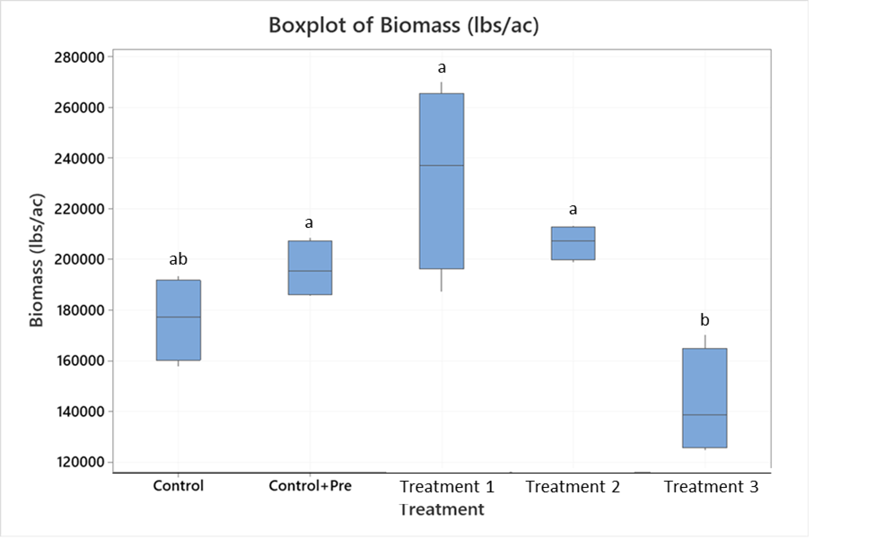

Figure 5. Fertilizer treatment effects on won bok yields. Bars conatining the same letters are not significantly different (P<0.05).

Based on the Scope of Services, a description of tasks expected to be completed in the next reporting period.

Description of tasks for next reporting period:

1. Demonstration trials are ongoing at Tolentino, Kaneshiro, Twin Bridges, Kahumana, MA’O, and Aloun Farms.

Summary of expenditures and in-kind contributions previously requested in comparison with the Contract’s project budget and remaining funds. The summary must be actual cumulative amounts for each line item (i.e., personnel services, travel, operating expenses, equipment acquisition, construction materials, other, etc.) current as of this quarterly status report. Please see the example on Page 4 if necessary.

Grant Funds

|  |  |  |  |  |  |
| --- | --- | --- | --- | --- | --- |
| No. | Description | Original Contract Amount | Contract Amounts from Preceding QSR | Expenditures during this Quarterly Reporting Period | Current Contract Amount (Remaining Funds) |
| A | Personnel Services | $244,440.28 | $0 | $22,764.29 | $ |
| B. | Travel | $1560 | $0 | $0 | $ |
| C. | Operating Expenses | $16,830 | $0 | $2,916.67 | $ |
| D. | Equipment | $1200 | $0 | $0 | $ |
| E. | Professional Services | $14,420 | $0 | $375.00 | $ |
| F. | Construction Materials and Supplies | $0 | $0 | $0 | $ |
| G. | Other Misc. Expenses | $1500 | $0 | $0 | $ |

TOTALS $279,950.28 $0.00 $26,055.96 $227,588.35

$137,105.55

In-Kind Contributions (Matching Funds)

|  |  |  |  |  |  |
| --- | --- | --- | --- | --- | --- |
| No. | Description | Original Contribution Amounts | Contribution Amounts from Preceding QSR | Contributions during this Quarterly Reporting Period | Current Contribution Amount |
| A | Personnel Services | $94,461.44 | $15,831.60 | $15,831.60 | $ |
| B. | Travel | $ | $ | $ | $ |
| C. | Operating Expenses | $ | $ | $ | $ |
| D. | Equipment | $ | $ | $ | $ |
| E. | Professional Services | $ | $ | $ | $ |
| F. | Construction Materials and Supplies | $ | $ | $ | $ |
| G. | Other Misc. Expenses | $ | $ | $ | $ |

TOTALS $94,461.44 $15,831.60

$34,047.80

In this ***example***, the Contract’s overall project budget for Personnel Services is $10,000.00, with $15,000.00 in Match. The Travel Budget is $1,200.00 with $1,000.00 in Match. Due to space constraints, Categories C - G were not listed in this example but shall be included with official QSRs and reimbursement requests. In the first Quarterly Grant Expense Report, the CONTRACTOR requests a $500.00 reimbursement, and claims $200.00 in Match:

Grant Funds

|  |  |  |  |  |  |
| --- | --- | --- | --- | --- | --- |
| No. | Description | Original Contract Amount | Contract Amounts from Preceding QSR | Expenditures during this Quarterly Reporting Period | Current Contract Amount (Remaining Funds) |
| A | Personnel Services | $10,000.00 | $0.00 | $500.00 | $9,500.00 |
| B | Travel | $1,200.00 | $0.00 | $0.00 | $1,200.00 |

TOTALS $11,200.00 $0.00 $500.00 $10,700.00

In-Kind Contributions (Matching Funds)

|  |  |  |  |  |  |
| --- | --- | --- | --- | --- | --- |
| No. | Description | Original Contribution Amounts | Contribution Amounts from Preceding QSR | Contributions during this Quarterly Reporting Period | Current Contribution Amount |
| A | Personnel Services | $15,000.00 | $0.00 | $200.00 | $14,800.00 |
| B | Travel | $1,000.00 | $0.00 | $0.00 | $1,000.00 |

TOTALS $16,000.00 $0.00 $200.00 $15,800.00

With QSR #2, the CONTRACTOR requests a $1,500.00 reimbursement and claims $500.00 in Match for Personnel, and $200.00 in Match for Travel (Note that the “Original Contract Amount” Column never changes, and the “Contract Amounts from Preceding QSR” Column in QSR #2 is identical to the “Current Contract Amounts” Column in QSR #1):

Grant Funds

|  |  |  |  |  |  |
| --- | --- | --- | --- | --- | --- |
| No. | Description | Original Contract Amount | Contract Amounts from Preceding QSR | Expenditures during this Quarterly Reporting Period | Current Contract Amount (Remaining Funds) |
| A | Personnel Services | $10,000.00 | $9,500.00 | $1,500.00 | $8,000.00 |
| B | Travel | $1,200.00 | $1,200.00 | $0.00 | $1,200.00 |

TOTALS $11,200.00 $10,700.00 $1,500.00 $9,200.00

In-Kind Contributions (Matching Funds)

|  |  |  |  |  |  |
| --- | --- | --- | --- | --- | --- |
| No. | Description | Original Contribution Amounts | Contribution Amounts from Preceding QSR | Contributions during this Quarterly Reporting Period | Current Contribution Amount |
| A | Personnel Services | $15,000.00 | $14,800.00 | $500.00 | $14,300.00 |
| B | Travel | $1,000.00 | $1,000.00 | $200.00 | $800.00 |

TOTALS $16,000.00 $15,800.00 $700.00 $15,100.00